COINS-Constantine I (306-337), 317 AE-Sol Invicto Comiti

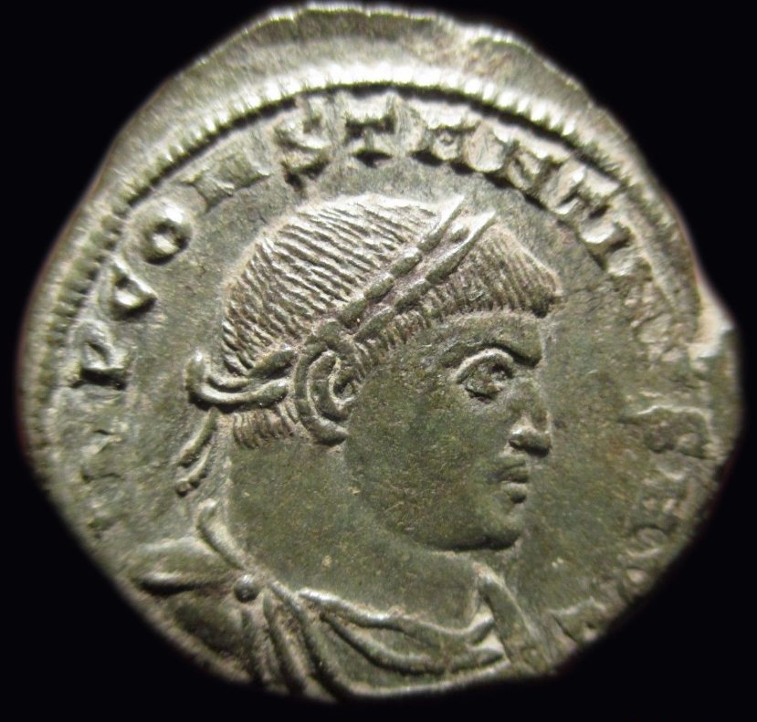 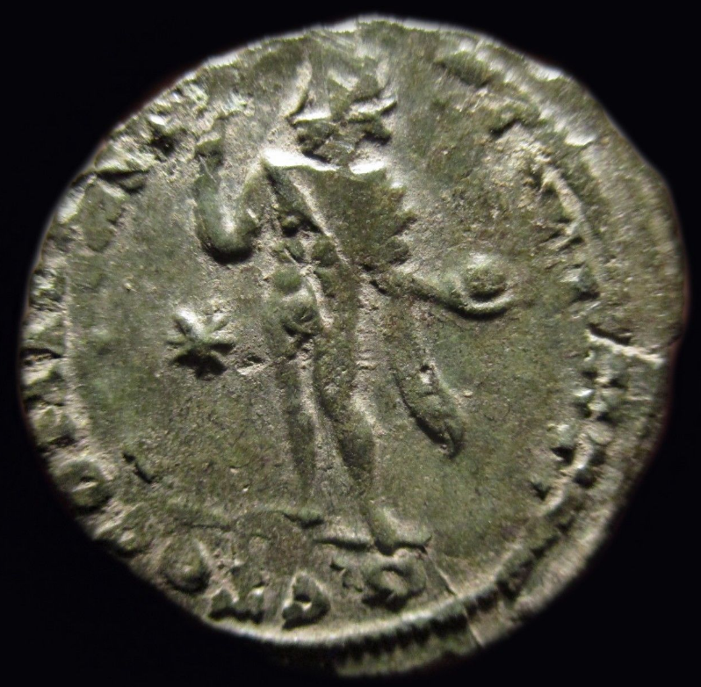

Constantine I (306-337), 317, AE,.

IMP CONSTANTINVS  AVG, laureate and cuirassed bust r.,

 Rv. SOL INVICTO COMITI, Sol standing l., holding globe and raising hand; Star in field

19mm 3.07gr

Sol’s Roman cult entered Rome in the very beginning probably with the Aurelii family of probable Sabine origin 1 and Titus Tatius (Varro) 1. Festus links the introduction of the cult of Sol to 2 the reputedly of Sabine origin, which suggests it may initially have been one of the sacra gentilicia.

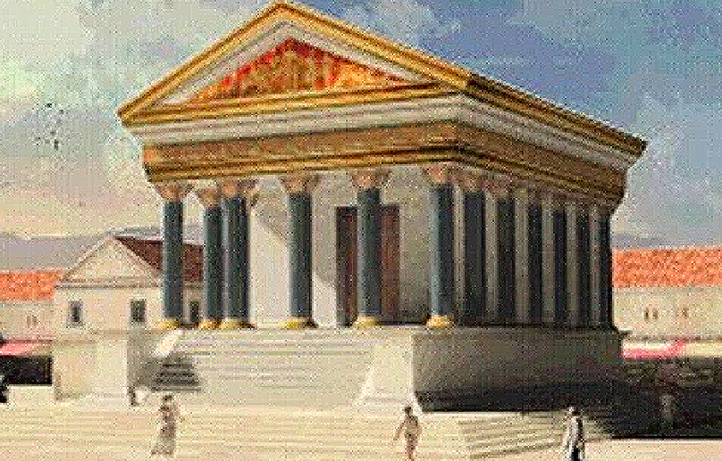

The Large Temple of Sol Invictus in Athens

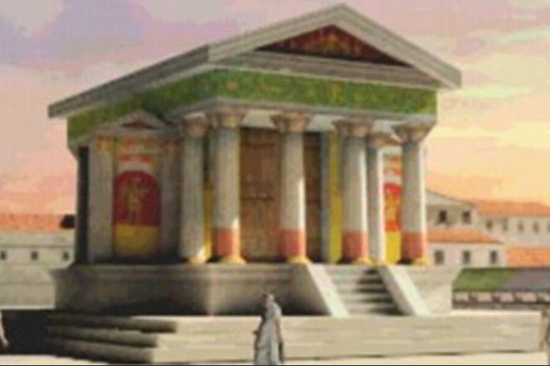

**Temple of Sol Invictus in Cyrene** was a temple in Cyrene (present-day Shahhat, [Libya](http://totalwar-ar.wikia.com/wiki/Libya)) dedicated to the pagan sun god Sol Invictus. Governor [Decentius Flavius](http://totalwar-ar.wikia.com/wiki/Decentius_Flavius" \o "Decentius Flavius) had the temple destroyed in 372 AD, replacing it with a Christian abbey and hermitage

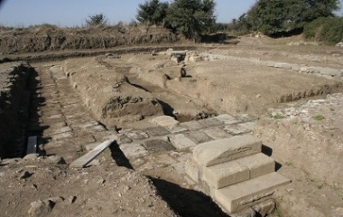

Temple of Sol

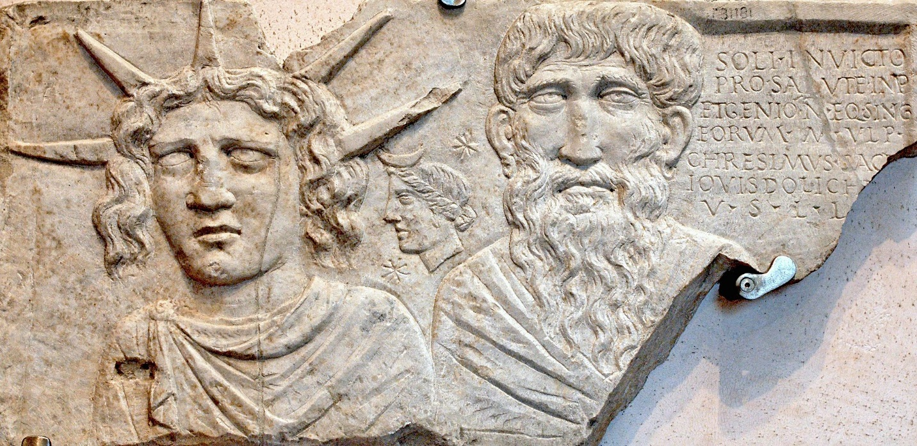

Votive plaque representing the Sun, the Moon and an old man, probably Jupiter Dolichenus. Provenance: barracks of the Singulares Equites, via Tasso in Rome. The Sun god crowned by solar rays, the Moon goddess bearing a crescent on her hair, and an old man, perhaps Jupiter Dolichenus. [Soli Invicto pro salute Imp(eratorum) et Genio n(umeri) eq(uitum) sing(ularium) eorum M. Ulp(ius) Chresimus sace[rd(os)] Iovis Dolich[eni] [dedicavit]] [Dedicated to Sol Invictus and to the Genius of the Imperial Batavian horseguards (*equites singulares*) for the emperors' health, by M. Ulpius Chresimus, priest of Jupiter Dolichenus] (CIL VI, 31181 = CIMRM 373 = M 239)

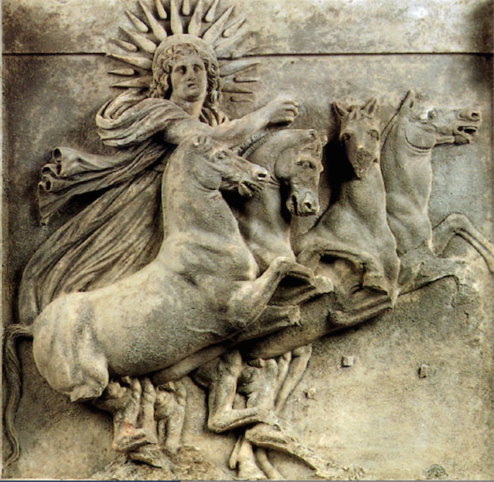

Dies Natalis Solis Invicti. Today is the day of birth of Sol Invictus, the unconquered sun. After <https://i.redd.it/nf66qf3u2m5y.png>



Lebanon Ruins of the temple of Sol, Balbek, After Rudisuhli-1880

https://www.redditstatic.com/desktop2x/img/renderTimingPixel.png The principal ruins of Baalbec occupy a position of considerable elevation above the surrounding village, which is formed entirely of massive substructures of masonry intersected by vaulted passages. Many of the stones of which this artificial acropolis is built are of prodigious size. In the western boundary wall there are three stones adjoining each other, at a considerable height from the ground, each of which, upon an average, is about sixty feet in length, twelve feet in thickness, and twelve feet in breadth. In the north boundary wall are eleven stones adjoining each other, varying from forty-five to fifty feet in length, six feet in thickness, and ten feet in breadth. Two ruined temples of extraordinary magnitude, with adjoining courts and propylaea, occupy the site of the acropolis, the principal approach to which, from the plain, was by an enormous flight of steps, vestiges of which still remain. The columns of the Great Temple, of which six only remain, are about seven feet in diameter, and fifty-five feet high: they are of the Corinthian order, and still support a portion of their entablature, which is elaborately carved, particularly the frieze, in which is a succession of bulls and lions in high relief. The smaller temple, commonly designated the Temple of the Sun, is in a much more perfect state as regards its external walls. Several of the columns, which are also of the Corinthian order, still remain erect: they are about six feet in diameter, and support an entablature of the same proportions and elaborate workmanship as that of the Great Temple. The principal entrance is highly enriched with arabesque and other sculpture. The interior is adorned with Corinthian columns partly engaged in the walls, and with two tiers of niches for statues in the intervening spaces. The architecture, of the courts and propylaea are of the same character and elaborate workmanship as the Temples.  Although these magnificent ruins bear undoubted evidence of their being a work of the Romans about the time of Antoninus Pius, there is reason to believe that a considerable portion of the substructions is of a much earlier date, probably of the time of the Jewish kings.

Sol was considered one of the region's ancestral deities, as he was the 3 father of Circe (of Monte Circeo), and thus the grandfather of Latinus. As one of the Di Indigetes he had a shrine and/or sacred grove on the banks of the Numicius, near Lavinium. Early imperial 4 fasti record a public sacrifice or festival for Sol Indiges on August 8 and/or 9 on the Quirinal, th th and agonalia on December 11 . The agonalia in particular attest to both the antiquity and the th 5 public nature of Sol’s cult. Only four such agonalia were held each year, performed at the Regia by the rex sacrificulus for the quintessentially Roman deities Janus (January 9 ), Mars (March th 17 ), and Vediovis (May 21 ), as well as Sol. Castagnoli suggests some linkage of the latter th st 6 with the Matralia for Mater Matuta on June 11, as they were held exactly six months apart.7 There was also a festival of some sort for Sol and Luna together, probably celebrated on August 28 . th 8

=======================================================

1 Paul. Fest. 22,5 L s.v. Aureliam. Santi (1991) is skeptical. 2 Varro L. 5,74, cf. Dion. Hal. Ant. 2,50,3, and Aug. C.D. 4,23 3 On Latinus and Sol cf. Verg. Aen. XII, 161-4. A lucus Solis by the Numicius is mentioned by Pliny, Nat. 3,56. 4 Solis is the unanimous mss reading here, and the emendation Iovis, proposed in the late 15 century by the Venetian scholar Ermolao Barbaro and adopted by most editions until recently, is unnecessary; cf. Dion. Hal. Ant. 1,55,2. Jaia 2009 reports on an excavation, currently still underway, of the probable remains of the temple of Sol Indiges. The meaning of indiges is not certain, but the notion that the di indigetes were ancestral Roman deities seems fairly secure. Cf. Koch 1933; Schilling 1979. On the name of the stream - Numicus or Numicius - cf. Kleine Pauly vol. 4, 197 s.v. Numicus. On the sacrificium publicum for Sol Indiges on the 8th of August, and/or feriae on the 9th of August cf. Fast. 5 Vall. (InscrItal XIII.2, 148-9), Allif. (InscrItal XIII.2 , 180-1), and Amit. (InscrItal XIII.2, 190-1). The 11th of December is marked as agonalia Indigeti in the Fast. Amit. (InscrIt XIII.2, 198-9), Ost. (InscrIt XIII.2, 106), Maff. (InscrIt XIII.2, 83), Praen. (InscrIt XIII.2, 136-7), and Ant. Min. (InscrIt XIII.2, 210). Lyd. Mens. 4, 155 links this specifically to Sol Indiges. Scullard 1981: 60-1, 91-2, 122, 203. 6 Castagnoli 1977: 472. 7 A festival celebrated on the 28th of August in honour of Sol and Luna is recorded in the Calendar of Filocalus 8 which dates to AD 354. A fragment of the Fast Praen. (InscrIt XIII.2, 134) also mentions Sol and Luna together and may be an early imperial reference to the same festival. Where this fragment belongs in the shattered calendar is uncertain. In its current state of preservation only four of the twelve months can be (partially) reconstructed and August is not one of them.

Ancient sacrifices in honor of the Sun Indiges -o Sol Indigete-. On August 9 rite receives the official name of Soli Indigiti in colle Quirinale, or the most specific of Solis Indigitis in colle Quirinale sacrificium publicum; On December 11, Agonium Solis Indigete (for more information see the Agonium festival).

Etymologies of sun and indigete

Not many authors consider that the name sun comes from the Etruscan word Usil, being the deity of light of the Etruscans, but also adopted by the Umbrians. In this case Varro, the great linguist, is wrong to look for the origin of the name sun. This is explained in his Latin Language V (68): "The Sun has its name, either because they call it the Sabines, or because only (Solus) he shines, so that from this god comes the light of day. "

The word indiges / indigete is more complex, although it can refer to various aspects of the deity:

Highlight its autochthonous origin, to distinguish it from other foreign solar divinities.

It simply means "that belongs to a site," in reference to Rome.

That has a specific work, being related to the word indigitamenta.

Wise sabino

The cult to the Sun was instituted, according to some authors, by the sabino king Tito Tacio, shortly after the foundation of Rome - to remember that this king governed next to Rómulo-; cult that in imperial times is confused with the cults of Helios and Apollo, both of Greek origin. This ancient Sun should not be confused with the cult of the Sun Unconquered, later and of oriental origin.

Aedes Solis et Lunae

Inside the famous Circus Maximus there is an old chapel in honor of the Sun Indiges, an honor it shares with the goddess Luna. The dies natalis of this sacred place is on August 28, although the year of its inauguration is unknown. On that day sacrifices are offered to both deities. Highlights a magnificent statue of the Sun Indiges driving a quadriga.

Solar myths in Lazio: Latino, Circe and the river Numicio

According to Virgil, in his Aeneid XII, the Latin god is the great-grandson of the solar god, as detailed in the following way when describing the king prepared for war:

"Latino is riding in his car

of majestic packaging that unites four steeds. They shine

around his temples the twelve golden rays,

the emblem of the Sun, its predecessor.

It is a curious genealogy, since he is usually considered the son of Fauno. In addition, ensures that the famous witch Circe is in turn daughter of the Sun and grandmother of Latino, living on the promontory known as Circeo, south of Lazio.

This Sol Indiges, in addition to Rome, receives special worship along the modest Numicio River, where it has altars along its banks. This river is located south of Lazio, between the towns of Lavinio and Ardea. His mythology is related to Anna Perenna and to Aeneas himself.

A geographical curiosity: the small Bantia

In addition, in the small town of Osca in Bantia, in the south of Italy, in Lucania, it is worth noting that the cult of the Sol Indiges is carried out jointly with Caelus Nocturnus - the night sky - representing both the entire sky. Strange cult so far from Rome, being the Sun Indiges of sabino origin.

Historical curiosity: the eclipse to the death of César

After the death of the great statesman and general, Virgil detailed in his Georgics I (465) a solar eclipse that caused great fear: it was considered a bad omen, a divine warning from the Sun itself. It seemed to be an especially long and dark eclipse, what caused panic and fear in the people:

 "Al Sol, who would dare to call him a liar? In truth it is he who often warns us of the hidden tumults that threaten and that deception and wars ferment in secret. He is also the one who, extinguished Caesar, felt sorry for Rome, covering his brilliant head with dark rust and provoking the fear of an eternal night to an ungodly generation. "

Pulvinar Solis

On August 9, a pulvinar is offered to the Sun along with a chapel dedicated to Quirino - near the Porta Quirinalis in the Servian wall - where the solar divinity has an altar inaugurated by Tito Tacio. The family that has the honor of organizing this rite is gens aurelia -name that means "golden", associating it with the sun, whose etymologies they share-. For the occasion a temporary platform adorned with cushions and cushions is created on a bed, in the style of a lectisternium, in which the divinity assists as the main guest: a reclining or seated statue is the main figure of this event. In addition, sacrifices are made in his honor. During this festival a banquet is offered to the deity and to the assistants. They are usually sumptuous meals in which the organizing family plays its prestige.

We do not know if the Agonium Solis Indigete of December 11 was organized by the gens aurelia, although it is unlikely, as it is a state sacrifice.